Use-Case Realization Report
Change State

Issue 3.0
Revision History
Date | Issue | Description | Author
19 July 2000 | 1.0 | Howard Russon | Howard Russon
2 August 2001 | 2.0 | Revised for MTech Unit 3 in 2001 | Howard Russon
21 July 2004 | 3.0 | Revised for MTech Unit 3 in 2004 | Howard Russon

Table of Contents
1. Brief Description 4
2. Flow of Events 4
2.1 Standard Flow 4
2.1.1 Change Drinks/Cash Stock 4
2.1.2 Lock the Door 4
2.2 Exceptions 4
3. Interaction Diagrams 5
3.1 Collaboration Diagram: Change Drink Store 5
3.2 Collaboration Diagram: Change Cash Store 5
3.3 Collaboration Diagram: Lock the Door 6
4. Participating Objects 6
5. Class Diagrams 7
5.1 Class Diagram: Change State 7
6. Derived Requirements 7

Use-Case Realization Report
Change State

Brief Description
This use case enables the Controller to perform the physical activities that the Maintainer would perform in the target implementation. Using the Machinery Simulator Panel, the Controller will be able to change the stock level for each brand or coin denomination, and to lock the vending machine door.

Flow of Events
The standard flow of events for this use case and any exceptions are described in the following subsections. The events are described in terms of Actors and Analysis Objects.

Standard Flow
This use case carries out two functions: changing drinks/cash stock levels and locking the Door. These are described below.

Change Drinks/Cash Stock
The flow of events is shown in sections 3.1 and 3.2 and described as follows:
- If the Controller changes the amount of cash of a denomination held in the machine, by typing into the Cash Store Display, on the Machinery Simulator Panel, then operation ChangeQuantity of Cash Store Display will use operation ChangeCoinQuantity of the Store Controller to update the Cash Store. To achieve this the following will occur:
- Operation FindDenomination of the Cash Store will be used to get a reference to the Coin of the required denomination.
- Operation SetQuantity of the Coin will be used to change the number of Coins of the denomination held.
- If the Controller changes the stock value of cans of a brand held in the machine, by typing into the Drinks Store Display on the Machinery Simulator Panel, then the operation ChangeStock of Drinks Store Display will use operation ChangeDrinkStock of the Store Controller to update the Drinks Store. To achieve this the following will occur:
- Operation GetItem of the Drinks Store will be used to return a reference to the Drink Store Item that corresponds to the brand.
- Operation SetQuantity of the Drink Store Item will be used to change the quantity of the brand held.

Lock the Door
The flow of events is shown in section 3.3 and described as follows:
- If the Controller presses the lock button of the Door Status Display on the Machinery Simulator Panel, then the operation LockDoor of the Door Status Display will use operation LockDoor of the Store Controller. The Store Controller will then instruct the Door to set its attribute to be locked. To do this the Door will use its operation SetState.
- The Store Controller will then use operation DeactivateDisplay of the Machinery Simulator Panel instructing it to deactivate the panel display objects (Door Status Display, Cash Store Display, and Drinks Store Display). To accomplish this, the display objects will use their respective Deactivate operations.

Exceptions
The following exceptions have been identified:
- Valid Ranges. When the Controller enters new stock levels, the system will check to ensure that the values are within valid ranges. In particular:
- Cash Store Display will check that the nuimber of Coins of each denomination are non-negative integer, and less than or equal to 40.
- Drinks Store Display will check that the number of cans of each Drinks Brand are non-negative integer, and less than or equal to 20.
- Door is Locked. If the vending machine door is locked then the Door Status Display, Cash Store Display, and Drinks Store Display will be deactivated. Hence current values will be displayed, but the Controller will not be permitted to make any changes to the values. The Door can only be opened by the Maintainer using a proper log-in function.

Interaction Diagrams

Collaboration Diagram: Change Drink Store
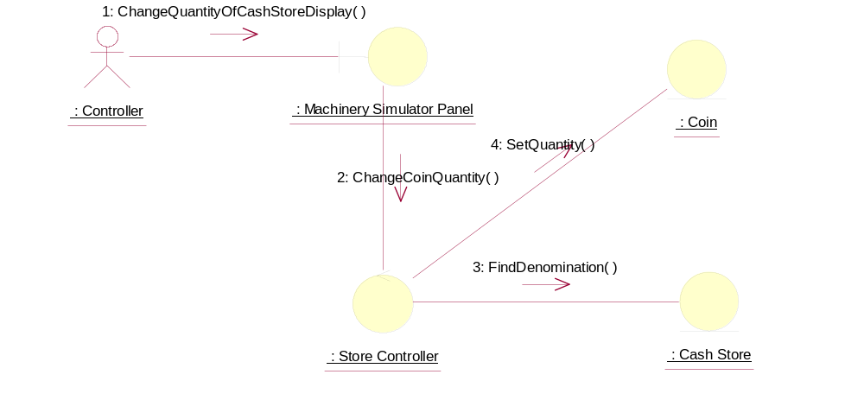

Collaboration Diagram: Change Cash Store
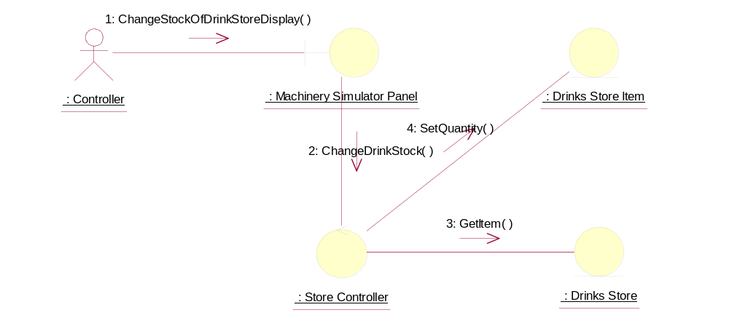

Collaboration Diagram: Lock the Door
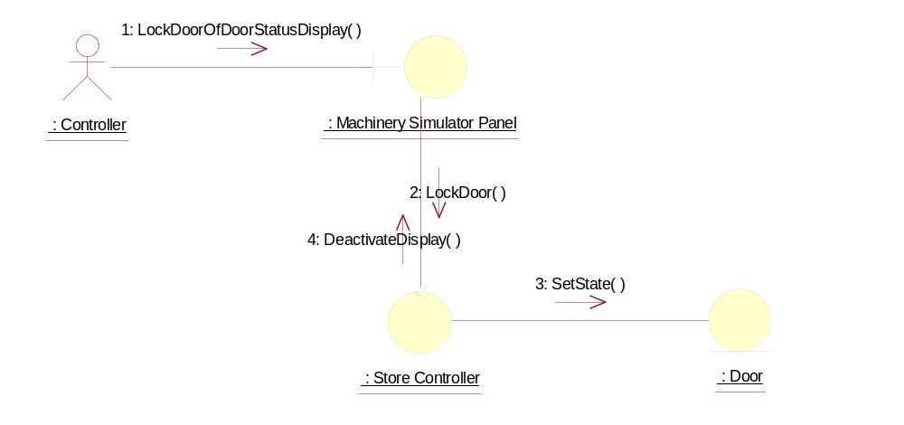

Participating Objects
: Cash Store
This object stores the weight and value of each type of Coin, and hence enables the machine to recognise each Coin entered.
: Coin
This object stores the weight and value of each type of Coin, and hence enables the machine to recognise each Coin entered.
: Controller
This actor represents the controller of the VMCS simulation. Hence it is only present in the simulated system (ie: this project) and would not be an actor of the target implementation. In particular, it performs several of the physical activities (ie: those that can not be provided by software) that are undertaken by the Maintainer in the target implementation, which include maintaining drink stocks and cash stocks inside the vending machine.
: Door
This object represents the door of the vending machine. It is opened so that the machine can be restocked with cans and cash.
: Drinks Store
The object is storage, in the vending machine's memory, for the total number of cans of each Drinks Brand held by the vending machine.
: Drinks Store Item
This represents a column of drinks in the vending machine. It can store a drink of any particular brand type.There can be as many drink store items as we desire in the vending machine. This number will be a configurable item for the vending machine.
: Machinery Simulator Panel
This panel simulates the physical actions of the maintainer. It enables the user to:
1 display and enter new values for the number of cans of each Drinks Brand held by the Drinks Store;
2 display and enter new values for the number of Coins of each denomination held by the Cash Store;
3 display whether the vending machine Door is unlocked, and enable it to be locked.
: Store Controller
This object controls the Change State use case. It mangages changes in Cash Store attributes and the Drinks Store attributes. It also handles the door status. It is also used by the Dispense Drink use case to update the Drinks Store attributes.

Class Diagrams

Class Diagram: Change State
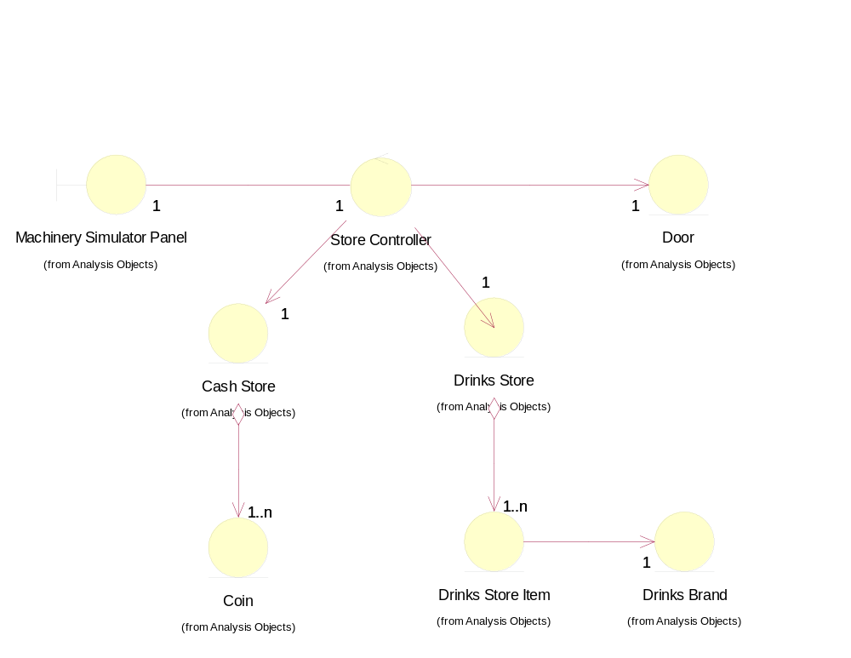

Derived Requirements
No special requirements have been identified.

